REPORT
SALES ANALYTICS
-By Kodela Navya
Abstract:
This project focuses on performing sales analytics for Northwind Traders using Excel, SQL, and Power BI to generate meaningful business insights from sales and operational data. The project aims to analyze customer behavior, product performance, employee distribution, supplier trends, and sales patterns to support data-driven decision-making.
The analysis process involved data cleaning, preprocessing, exploratory data analysis (EDA), SQL-based querying, and interactive dashboard creation. SQL was used to perform analytical queries and extract insights related to customer orders, product sales, employee trends, supplier distribution, and revenue performance. Excel was utilized for data preprocessing and exploratory analysis, while Power BI was used to create interactive dashboards and visualizations for effective business reporting.
The project successfully identified key trends such as top-performing products, high-value customers, regional sales distribution, seasonal demand patterns, and supplier contributions. The Power BI dashboards provide a comprehensive and visually interactive representation of business performance through charts, maps, KPI cards, and filters.
Overall, this project demonstrates how data analytics and visualization techniques can help organizations monitor performance, identify opportunities, and improve business decision-making processes.
Problem Statement
Northwind Traders generates large volumes of sales and operational data across multiple business areas including customers, orders, products, employees, suppliers, shipping, and product categories. However, without proper analysis and visualization, it becomes difficult to identify business trends, customer purchasing behavior, product performance, inventory insights, and operational efficiency.
The objective of this project is to analyze the Northwind dataset using Excel, SQL, and Power BI to generate meaningful business insights and support data-driven decision-making. The project integrates data from 8 different tables — Customers, Orders, Order Details, Products, Categories, Employees, Suppliers, and Shippers — to provide a comprehensive analysis of business operations.
The project focuses on analyzing customer behavior, sales trends, employee distribution, supplier performance, product demand, and regional sales patterns. SQL was used for exploratory data analysis and querying, Excel was used for preprocessing and analysis, and Power BI was used to build interactive dashboards and visualizations.
The main goal of this project is to create a visually interactive and user-friendly dashboard that helps stakeholders monitor key performance indicators, identify trends, and make informed business decisions. The expected outcome is to improve business understanding and operational efficiency through analytical reporting and visualization techniques.
Table Explanations
1. Customers Table
The Customers table stores information related to the company’s customers. It contains details such as Customer ID, Company Name, Contact Name, Contact Title, Address, City, Region, Postal Code, Country, Phone Number, and Fax Number.
2. Orders Table
The Orders table contains information about customer orders placed with Northwind Traders. It includes details such as Order ID, Customer ID, Employee ID, Order Date, Required Date, Shipped Date, Freight Charges, Ship Address, Ship City, Ship Region, Ship Postal Code, and Ship Country.
3. Order Details Table
The Order Details table contains transaction-level details for each order. It stores information such as Order ID, Product ID, Unit Price, Quantity Ordered, and Discount applied to products. This table helps analyze sales quantity, revenue, and product performance.
4. Products Table
The Products table stores product-related information including Product ID, Product Name, Supplier ID, Category ID, Quantity Per Unit, Unit Price, Units In Stock, Units On Order, Reorder Level, and Product Discontinued Status.
5. Categories Table
The Categories table contains information about different product categories available in the business. It includes Category ID, Category Name, and Category Description.
6. Employees Table
The Employees table stores employee-related information such as Employee ID, Employee Name, Job Title, Hire Date, Birth Date, Address, City, Country, Extension Number, Reporting Manager, and Employee Notes.
7. Suppliers Table
The Suppliers table contains supplier-related details including Supplier ID, Company Name, Contact Name, Contact Title, Address, City, Region, Postal Code, Country, Phone Number, and Fax Number.
8. Shippers Table
The Shippers table stores information about shipping companies responsible for delivering orders. It includes Shipper ID, Company Name, and Phone Number.
Data Cleaning and Preprocessing
Data cleaning and preprocessing were performed to ensure data quality, consistency, and accuracy before conducting analysis in SQL, Excel, and Power BI. Since the Northwind dataset contains multiple related tables, preprocessing was essential to validate relationships and prepare the data for analytical reporting.
The cleaned datasets were organized and stored separately for further analysis and dashboard development.
Data Cleaning Steps Performed
In Excel
- Checked for missing or null values
- Removed duplicate records
- Standardized date formats
- Verified column data types
- Corrected inconsistent entries and formatting issues
- Validated data consistency across tables
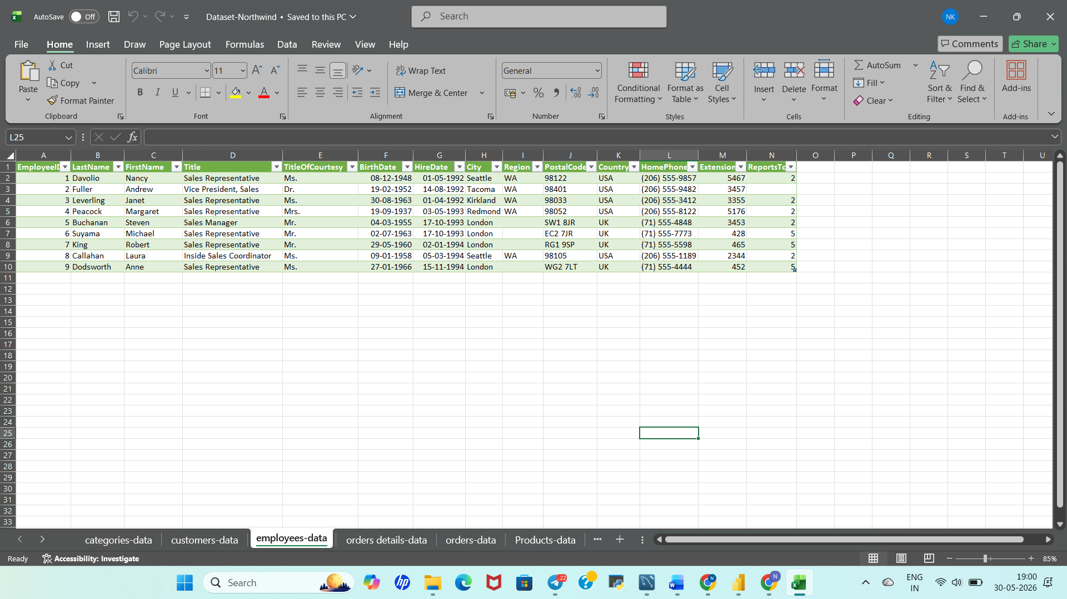
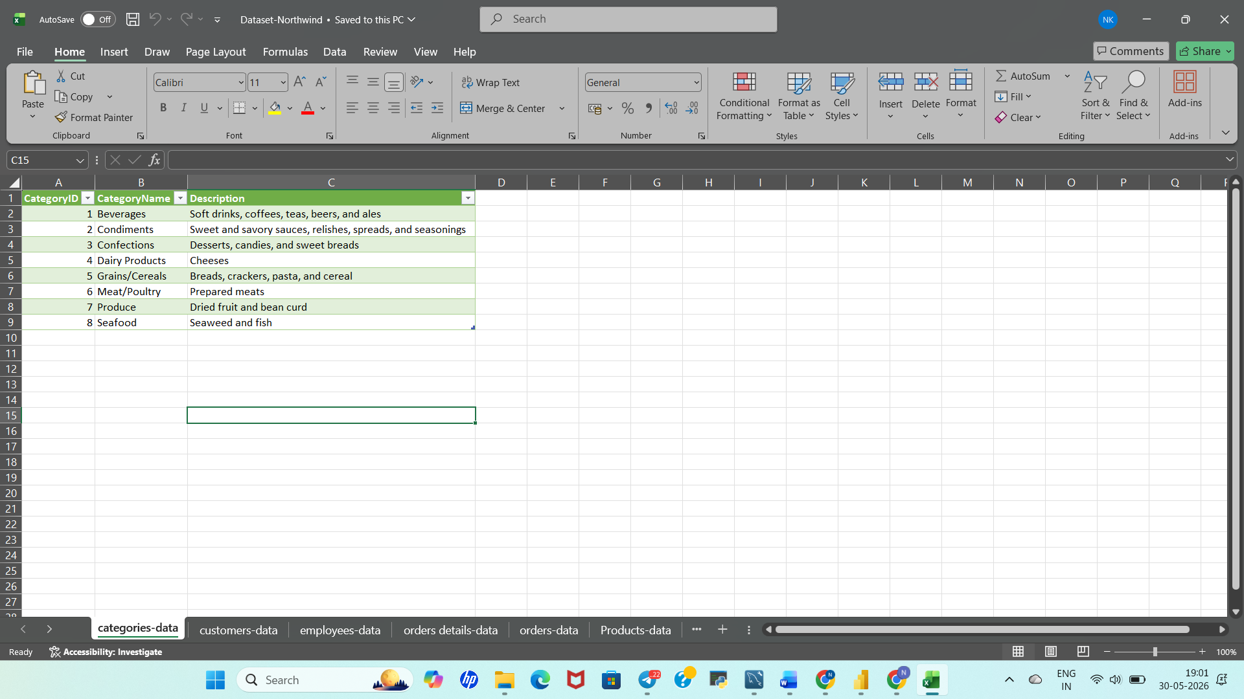
In SQL
- Verified primary key and foreign key relationships
- Checked for null or invalid records using SQL queries
- Validated joins between tables
- Filtered unnecessary or inconsistent records
- Ensured accurate mapping between related tables
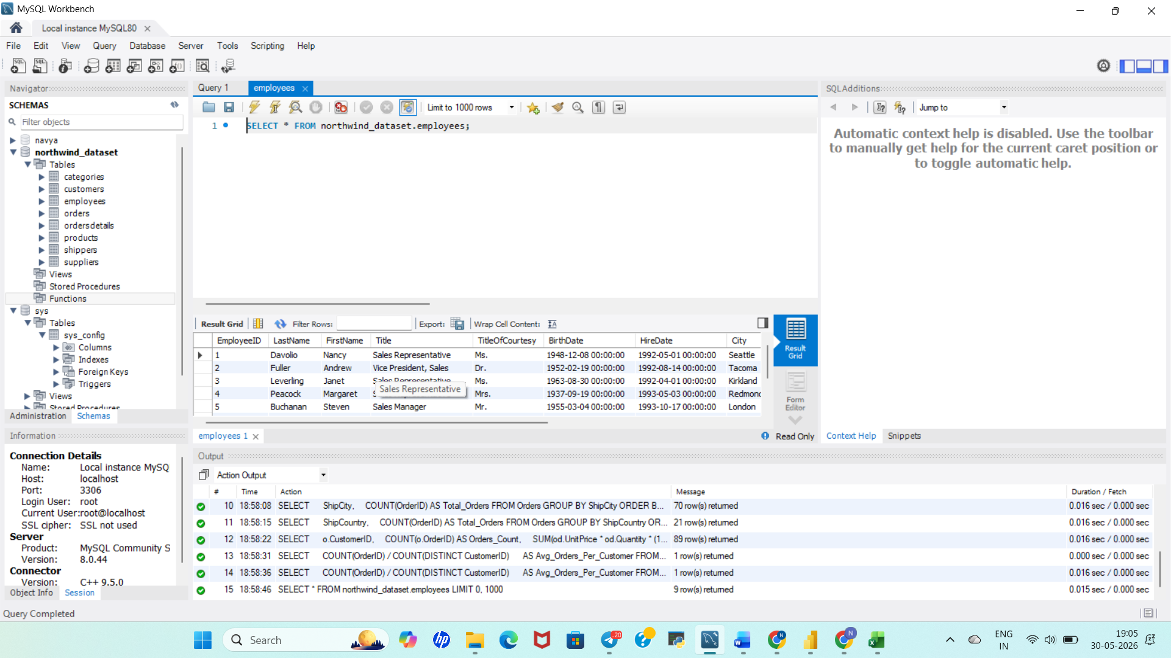
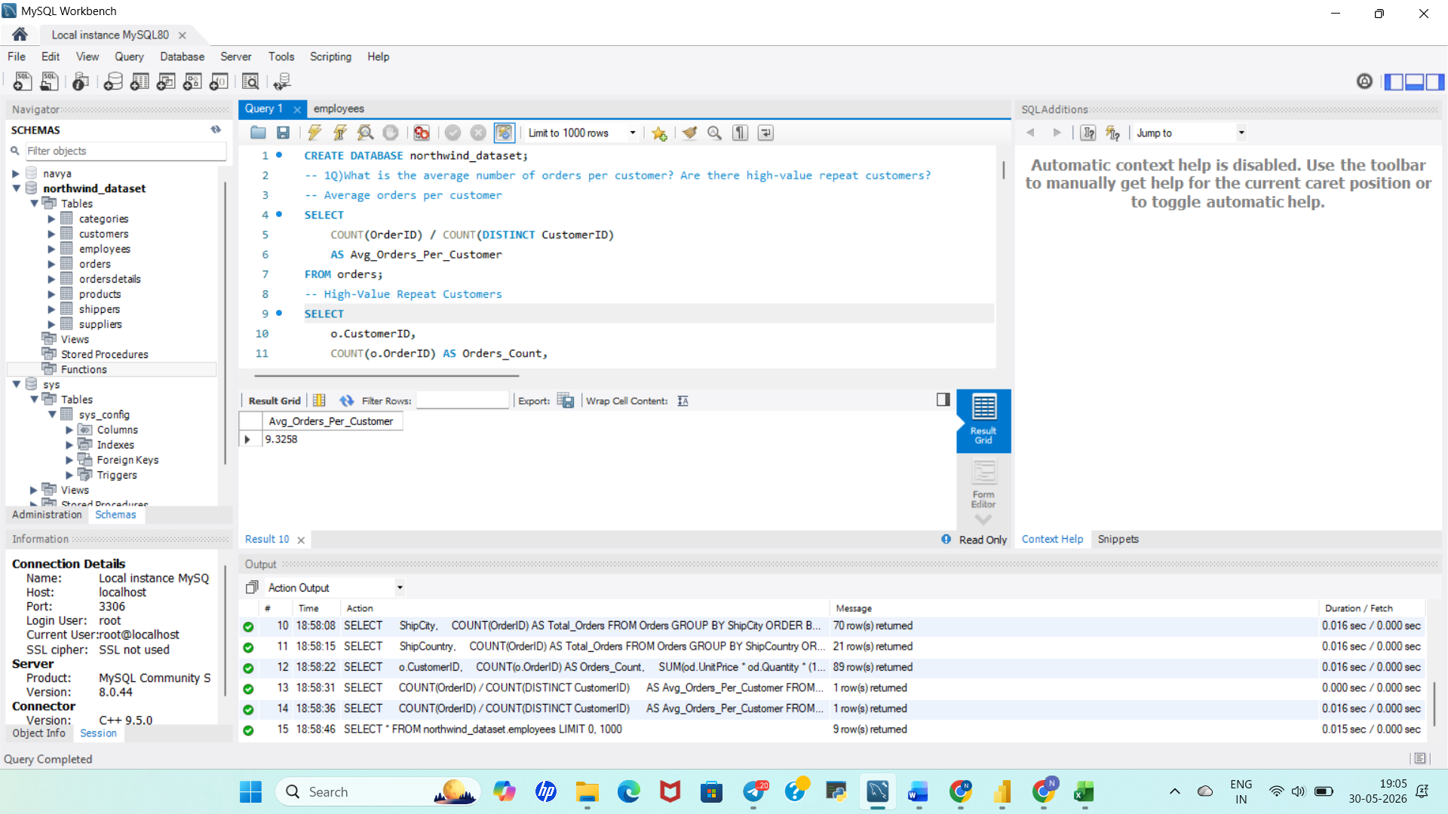
Data Preprocessing
The preprocessing stage involved organizing and preparing the data for analysis and visualization.
Preprocessing Activities
- Combined related tables using joins
- Created calculated fields for analysis
- Prepared aggregated data for reporting
- Organized datasets for Power BI dashboard creation
- Structured data for trend and performance analysis
Tools Used
- Microsoft Excel
- MySQL Workbench
- Power BI
Outcome
After cleaning and preprocessing, the dataset became suitable for:
- Exploratory Data Analysis (EDA)
- SQL-based analytical querying
- Dashboard visualization in Power BI
- Business insight generation and reporting
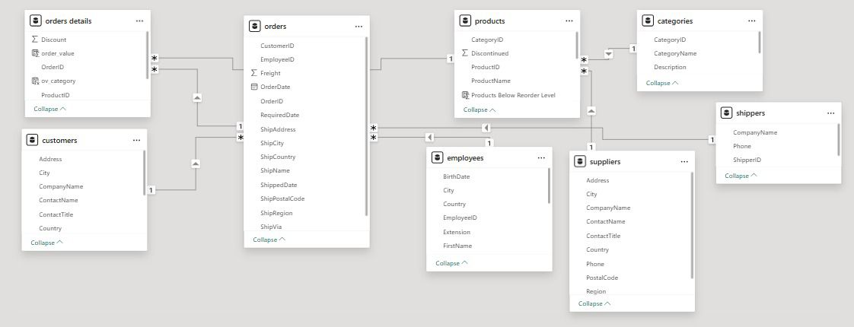
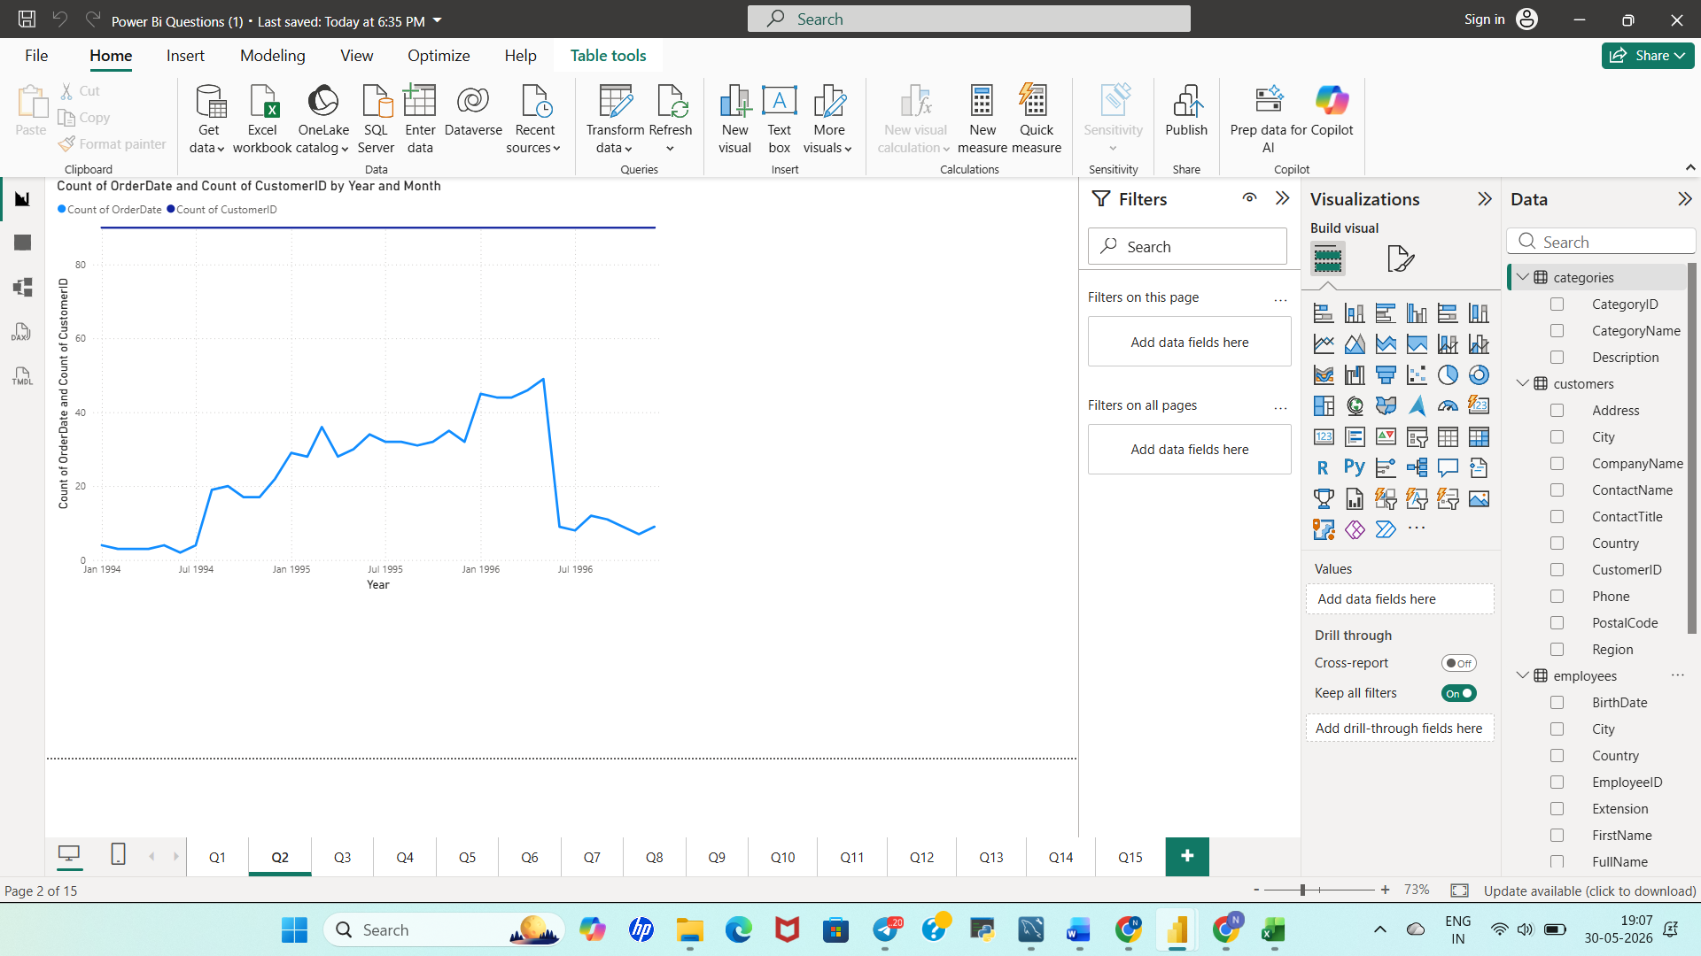

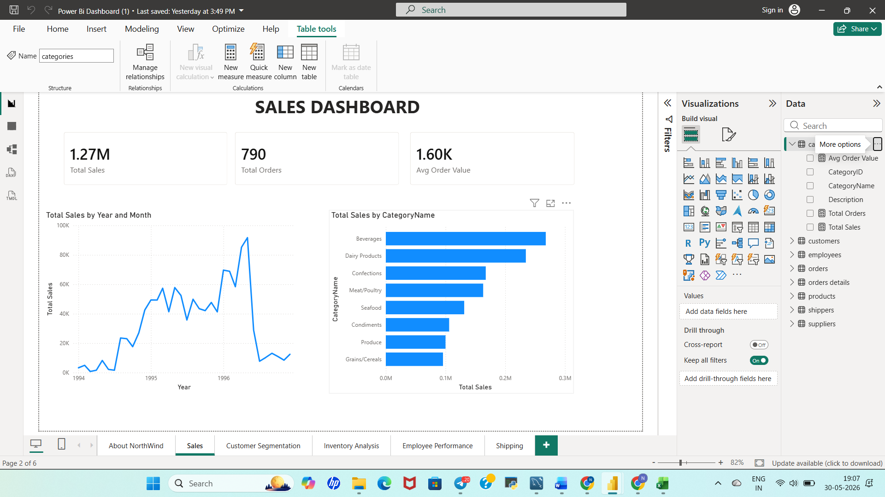

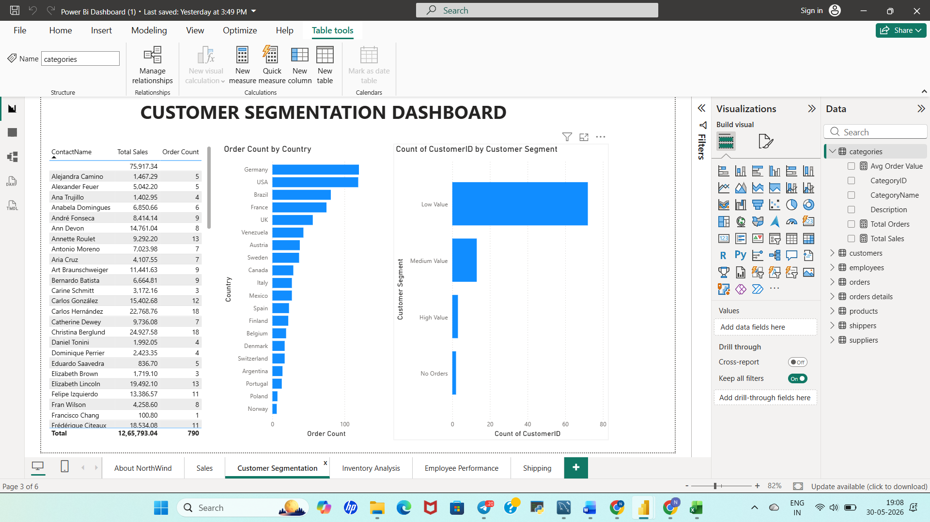

SQL Exploratory Data Analysis (EDA)
Question 1
What is the average number of orders per customer? Are there high-value repeat customers?
Objective:
To analyze customer purchasing behavior and identify customers who place frequent orders and generate high revenue.
Insight:
The average number of orders per customer is approximately 9.33. Customers such as QUICK, ERNSH, and SAVEA placed significantly more orders than average and generated high revenue, making them valuable repeat customers for the business.
Question 2
How do customer order patterns vary by city or country?
Objective:
To analyze geographical differences in customer ordering behavior.
Insight:
Germany and the USA generated the highest order volumes. Cities such as Rio de Janeiro, London, and São Paulo contributed significantly to total orders. Some countries exhibited higher average orders per customer, indicating stronger customer loyalty.
Question 3
Can we cluster customers based on total spend, order count, and preferred categories?
Objective:
To segment customers according to spending behavior and purchasing preferences.
Insight:
Customers can be grouped into high-value, medium-value, and low-value segments. High-value customers demonstrated higher order frequency and concentrated spending in categories such as Beverages and Dairy Products.
Question 4
Which product categories or products contribute most to order revenue?
Objective:
To identify top-performing products and categories based on revenue contribution.
Insight:
The Beverages category generated the highest revenue, followed by Dairy Products and Confections. Products such as Côte de Blaye contributed significantly to overall sales revenue.
Are there any correlations between orders and customer location or product category?
Objective:
To determine whether purchasing behavior varies across regions and product categories.
Insight:
Customer purchasing patterns differed across regions, with certain countries showing stronger demand for specific product categories. This indicates regional preferences and targeted market opportunities.
Question 5
How frequently do different customer segments place orders?
Objective:
To compare ordering frequency among different customer groups.
Insight:
High-value customers placed substantially more orders than medium-value and low-value customers. A relatively small customer segment contributed a large share of total business activity.
Question 6
What is the geographic and title-wise distribution of employees?
Objective:
To understand workforce distribution across locations and job roles.
Insight:
Most employees are concentrated in the USA and UK regions. Sales Representatives constitute the largest employee group, highlighting the company's strong focus on sales operations.
Question 7
What trends can we observe in hire dates across employee titles?
Objective:
To identify hiring patterns across different employee roles.
Insight:
Employee hiring increased during specific years, particularly for Sales Representatives. The hiring trend reflects periods of business expansion and workforce growth.
Question 8
What patterns exist in employee title and courtesy title distributions?
Objective:
To analyze employee designation structures and courtesy title representation.
Insight:
Sales Representatives form the majority of employees. Courtesy titles such as Ms. and Mr. are the most commonly used across the organization.
Question 9
Are there correlations between product pricing, stock levels, and sales performance?
Objective:
To examine how pricing and inventory levels influence product sales.
Insight:
Products with balanced pricing and adequate stock availability generally achieved stronger sales performance. Some products maintained high sales despite lower inventory levels.
Question 10
How does product demand change over months or seasons?
Objective:
To identify seasonal trends in product demand.
Insight:
Demand increased steadily during the first half of the year, peaked around May, and then fluctuated during later months. This indicates seasonal purchasing behavior.
Question 11
Can we identify anomalies in product sales or revenue performance?
Objective:
To detect products with unusually high or low sales performance.
Insight:
Certain products generated exceptionally high revenue and sales volume compared to others. These products can be considered key revenue drivers for the business.
Question 12
Are there any regional trends in supplier distribution and pricing?
Objective:
To analyze supplier presence and pricing variations across regions.
Insight:
The USA, France, and Germany have the highest supplier concentration. Product pricing differs across regions, indicating geographical pricing variations.
Question 13
How are suppliers distributed across different product categories?
Objective:
To evaluate supplier participation across product categories.
Insight:
Categories such as Beverages and Seafood have a larger supplier base, while some categories rely on a smaller number of specialized suppliers.
Question 14
How do supplier pricing and categories relate across different regions?
Objective:
To examine the relationship between supplier pricing, product categories, and geographical regions.
Insight:
Supplier pricing varies significantly across countries and categories. Regional supplier specialization influences both pricing patterns and category performance.

Power BI Analysis Insights
Question 1
How does customer distribution vary across different countries or cities?
Insight:
Customers are concentrated in a few key countries and cities, indicating stronger market presence in those regions. Certain cities contribute significantly more customers than others, highlighting potential target markets for business expansion.
Question 2
What is the trend in customer orders over time?
Insight:
Customer orders fluctuate over time, with certain periods showing higher order activity. The trend indicates consistent customer engagement and recurring demand patterns.
Question 3
What is the distribution of customers by Contact Title or Region?
Insight:
Customers are distributed across multiple contact titles and regions. Some customer segments contribute a larger share of the customer base, helping identify major customer groups.
Question 4
How does order volume change over time?
Insight:
Order volume varies across different months and years, reflecting changing customer demand. Peak periods indicate increased purchasing activity and business growth opportunities.
Question 5
What is the distribution of order values?
Insight:
Most orders fall within a moderate value range, while a small number of orders generate exceptionally high revenue. These high-value transactions contribute significantly to total sales.
Question 6
What is the average order shipping duration?
Insight:
The average shipping duration remains relatively stable across orders. However, a few orders experience longer delivery times, indicating potential opportunities for logistics improvement.
Question 7
What is the count of employees by job title or region?
Insight:
Sales Representatives form the largest employee group, demonstrating the organization's strong sales focus. Employee distribution varies across different regions based on operational requirements.
Question 8
What is the distribution of employee tenure?
Insight:
Employee tenure varies considerably, indicating a balanced workforce consisting of both experienced employees and recently hired staff.
Question 9
What is the reporting structure among employees?
Insight:
The reporting hierarchy clearly identifies managerial relationships and employee reporting lines, supporting efficient organizational management.
Question 10
Which products have the highest sales volume?
Insight:
A small number of products contribute a significant share of total sales volume. These products represent the company's top-performing items and key revenue drivers.
Question 11
How does the sales volume vary across different product categories?
Insight:
Sales volume differs significantly across categories, with certain categories consistently outperforming others and contributing a larger share of overall sales.
Question 12
Can we visualize the pricing distribution of products?
Insight:
Product prices vary widely across the catalog. Most products are moderately priced, while a few premium products occupy the higher end of the pricing spectrum.
Question 13
How many products are supplied by each supplier?
Insight:
Supplier contributions are unevenly distributed. Some suppliers provide a large number of products, whereas others focus on supplying a limited product range.
Question 14
How does product pricing vary across different suppliers?
Insight:
Pricing strategies differ among suppliers. Certain suppliers specialize in premium-priced products, while others focus on products within lower or moderate price ranges.
Question 15
What is the geographical distribution of suppliers?
Insight:
Suppliers are spread across multiple countries and regions. Some regions have a higher concentration of suppliers, indicating stronger supplier networks and sourcing capabilities.
Challenges Faced
During the development of the Sales Analytics Project, several challenges were encountered:
- Managing and understanding relationships among the 8 interconnected tables in the Northwind database.
- Performing data cleaning and validation to ensure consistency and accuracy before analysis.
- Writing complex SQL queries involving multiple table joins, aggregations, and analytical calculations.
- Identifying meaningful business insights from large volumes of sales, customer, product, employee, and supplier data.
- Creating appropriate visualizations for different business questions and selecting the most effective charts in Power BI.
- Building relationships between tables and maintaining data integrity within the Power BI data model.
- Designing an interactive and user-friendly dashboard while ensuring visual clarity and readability.
- Analyzing seasonal sales trends, customer purchasing behavior, and supplier performance across multiple dimensions.
- Organizing project documentation, screenshots, SQL outputs, and dashboard visuals in a structured and professional format.
- Converting analytical findings into actionable business insights and recommendations for decision-making.
Despite these challenges, the project was successfully completed through systematic data analysis, visualization techniques, and continuous validation of results.
Conclusion
The Sales Analytics Project successfully utilized Excel, SQL, and Power BI to analyze the Northwind dataset and generate meaningful business insights. By integrating data from eight interconnected tables—Customers, Orders, Order Details, Products, Categories, Employees, Suppliers, and Shippers—the project provided a comprehensive view of the company's sales and operational performance.
Through SQL-based exploratory data analysis, key patterns related to customer behavior, product performance, employee distribution, supplier trends, and sales performance were identified. Excel was used for data cleaning and preprocessing, ensuring the accuracy and consistency of the dataset before analysis. Power BI dashboards enabled interactive visualization of business metrics, making it easier to understand trends and support decision-making.
The analysis revealed valuable insights regarding high-value customers, top-performing products, regional sales distribution, supplier contributions, employee structure, and seasonal demand patterns. These findings can help businesses improve customer retention, optimize inventory management, enhance supplier strategies, and make informed business decisions.
Overall, this project demonstrates the effectiveness of data analytics and visualization techniques in transforming raw data into actionable insights, enabling organizations to improve operational efficiency and support data-driven decision-making.

